

Topic : Online Land Sales Management System

Group no : KNDUNI_04

Campus : Kandy Uni

Submission Date:

We declare that this is our own work and this Assignment does not incorporate without acknowledgment any material previously submitted by anyone else in SLIIT or any other university/Institute. And we declare that each one of us equally contributed to the completion of this Assignment.

|  |  |  |
| --- | --- | --- |
| **Registration No** | **Name** | **Contact Number** |
| IT23255142 | HANA .S.M.F | 0778789282 |
| IT23151710 | AAZAF RITHA .J | 0760737173 |
| IT23262768 | RESHMA .M.R.F | 0769065052 |
| IT23187078 | AMAN MOHAMED .M.A | 0744050889 |
| IT23238480 | AYMAN .M.R | 0770847864 |

**Content**

# Description of the requirements.

# Classes Identified

# CRC Card

# Class diagram

# Coding for the classes

# Individual contributions

# Description of the requirements.

# There are four types of users.

# Those are admin, agent, financial officer, and users (Registered or Unregistered).

# All the users can view the websites, check availability of the lands, check price ranges, check the FAQ sections, make buy requests, make requests for sell the lands and, contact with the admin.

# Any guest can register for the website by providing a first name, last name, address, password, date of birth, phone number, and email address.

# After registering, the system registered users can login using their email address and password.

# Registered users can check land packages and make requests to buy the lands.

# Registered users can make requests to sell land and contact with agents.

# Registered users can give feedback about the website.

# Registered users can view, delete, or edit their profiles.

# Registered users can view, delete, or edit their land sell requests.

# Agent can login with their email address and password.

# Agents can generate progress and customer service reports.

# Agents can contact the seller and check the given land details.

# If given details verified by agents can request to admin to approve the land sell proposal.

# Agents can contact buyer and negotiate with them and sell the land.

# Admins can login with their email address and password.

# Admin can approve or decline the user land sell requests.

# The admin can activate and delete the user accounts.

# The admin can edit, delete, and view the land details on database.

# The admin can activate and delete the employee accounts.

# The admin can activate and delete the financial officers’ accounts.

# Admin can approve or decline transactions contact with financial officers.

# Financial officers can generate finance reports.

# Financial officers should communicate with buyers and decide payment methods.

# Classes Identified

# User

# Registered User

# Agent

# Admin

# Financial Officer

# Land

# Profile

# Transaction

# Report

# Feedback

# CRC Card

|  |  |
| --- | --- |
| Class: Agent | |
| Responsibilities | Collaborations |
| Login to account |  |
| Approve Requests |  |
| Verify land details |  |
| Requests for land sale approval | Admin |
| Contacts buyer | Registered User |
| Contacts seller | Registered User |
| Generate reports | Reports |

|  |  |
| --- | --- |
| Class: Inquiry | |
| Responsibilities | Collaborations |
| Show details about inquiry |  |
| Show inquiry |  |

|  |  |
| --- | --- |
| Class: User | |
| Responsibilities | Collaborations |
| Register to account |  |
| Search Land ads | Land |
| Contact websites |  |
| Check FAQs |  |
| Check feedbacks | Feedback |
| View about us |  |
| Bookmark land interested | Land |

|  |  |
| --- | --- |
| Class: Land | |
| Responsibilities | Collaborations |
| Stores land details |  |
| Manage land details |  |

|  |  |
| --- | --- |
| Class: Registered User | |
| Responsibilities | Collaborations |
| Login to the system |  |
| Send inquiry | Admin |
| Post Land Ad |  |
| Enter land details | Land |
| Edit land details | Land |
| Request for property buying | Agent |
| Request for property selling | Agent |
| Cancel request |  |
| Post feedback | Feedback |

|  |  |
| --- | --- |
| Class: Feedback | |
| Responsibilities | Collaborations |
| Details about feedback |  |
| Approved feedback | Admin |

|  |  |
| --- | --- |
| Class: Report | |
| Responsibility | Collaborators |
| Generate customer service reports | Agent |
| Generate finance reports | Financial Officer |
| Generate progress reports | Agent |

|  |  |
| --- | --- |
| Class: Admin | |
| Responsibility | Collaborators |
| Login |  |
| View user profiles and verify them | Registered User, Financial Officer, Agent |
| Add/ delete and edit users accounts | Registered User, Financial Officer, Agent |
| Reply inquiry | Registered User |
| Approve or decline transactions | Financial Officer, Transaction |
| Manage land details |  |
| Approve or decline land requests | Registered User, Agent |
| Monitor system |  |
| View reports | Reports |
| View feedback | Feedback |

|  |  |
| --- | --- |
| Class: Financial Officer | |
| Responsibilities | Collaborations |
| Manage risk |  |
| Manage expense |  |
| Manage treasury |  |
| Generate financial reports | Reports |
| Contacts buyer | Registered User |
| Contacts Seller | Registered User |

|  |  |
| --- | --- |
| Class: Transaction |  |
| Responsibilities | Collaborations |
| Store land sales transaction details |  |
| Store land purchase transaction details |  |
| Maintain transaction history |  |
| Validate transaction data | Financial Officer |

# 04.Class diagram

# 

# 05.Coding for the classes

# 1.Main.cpp

# 

# 2.User.cpp and User.h

# 

# A screenshot of a computer code Description automatically generated3.Registered User.h

# 4.Registered user.cpp

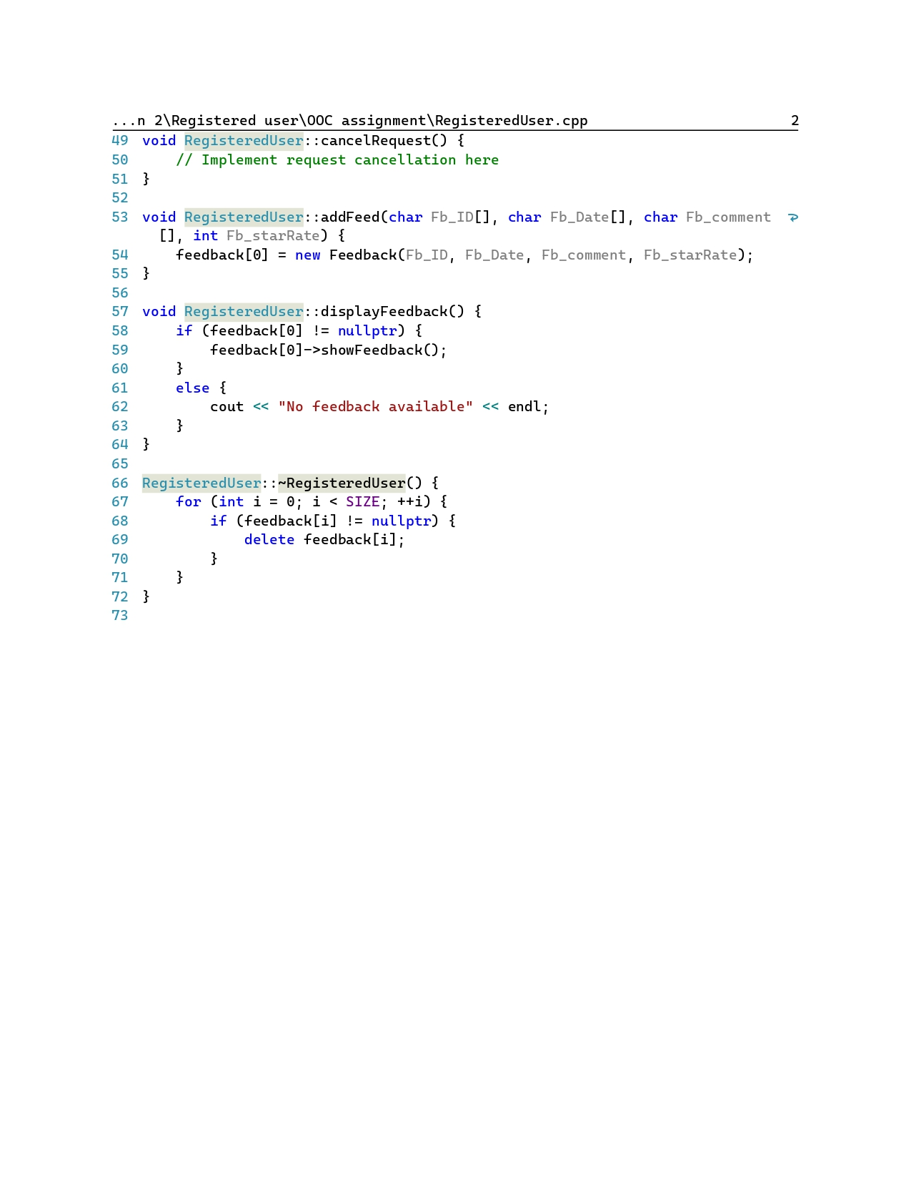

# 5.Admin.cpp

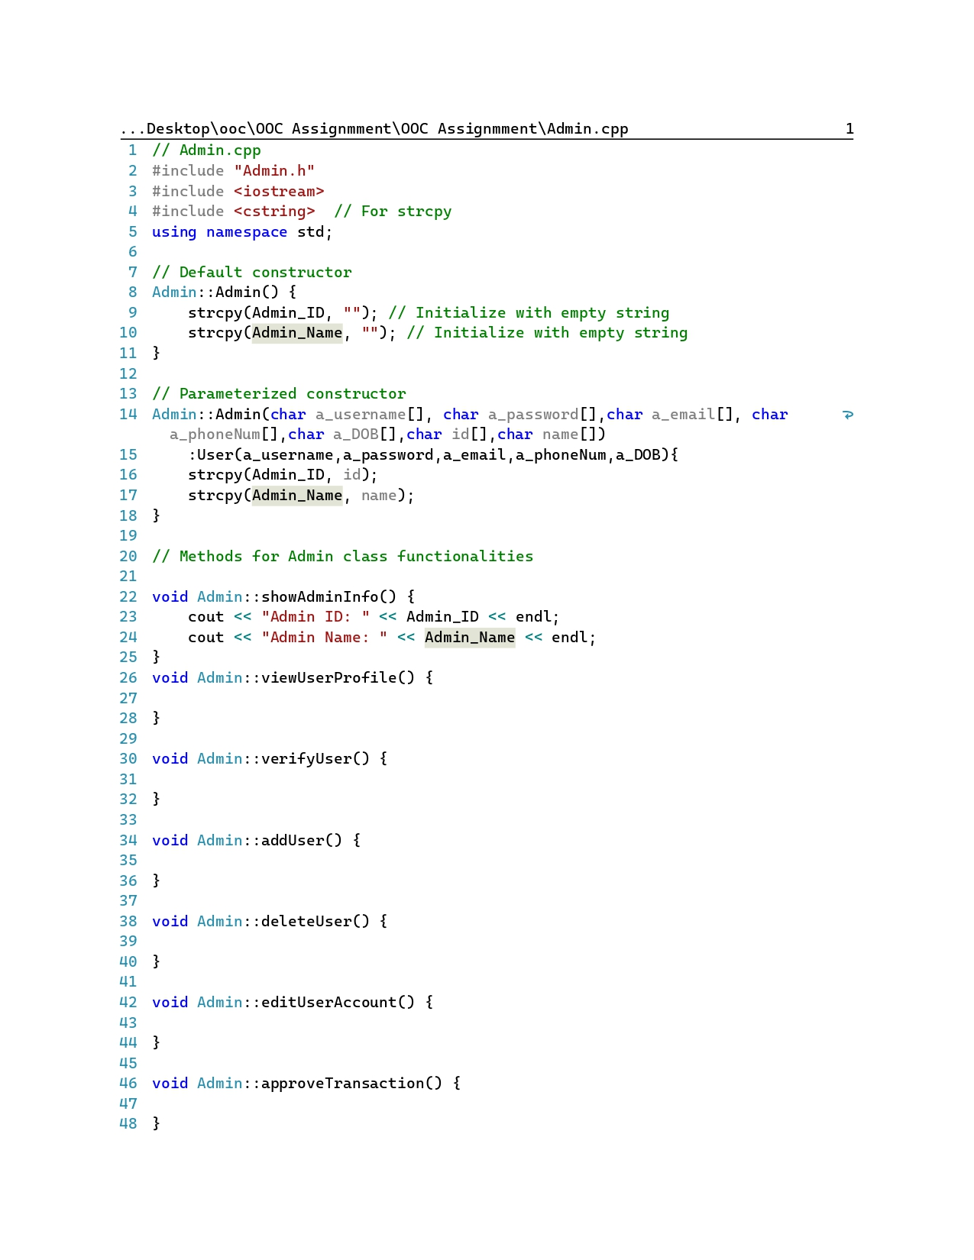

# 

# 6.Admin.h

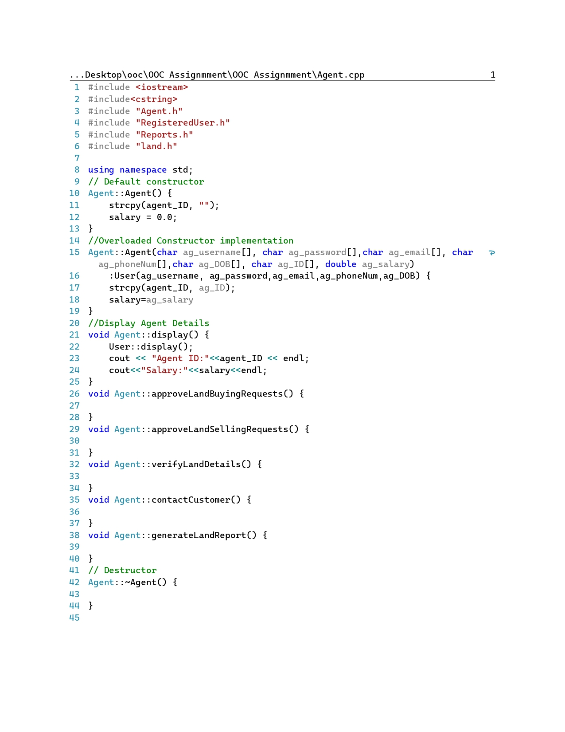**7.Agent.cpp**

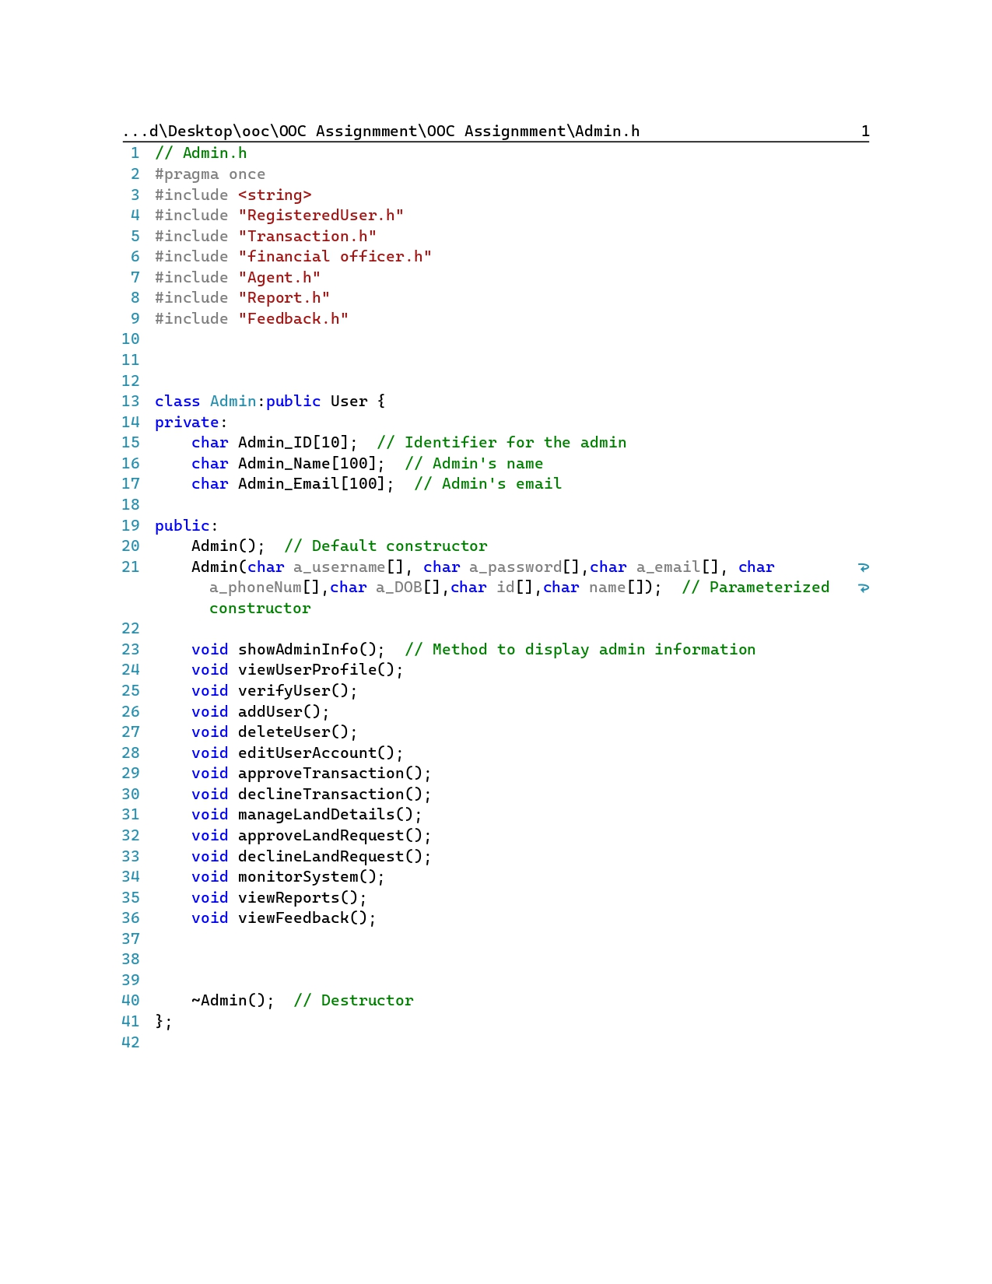**8.Agent.h**

# 9.Transection.h

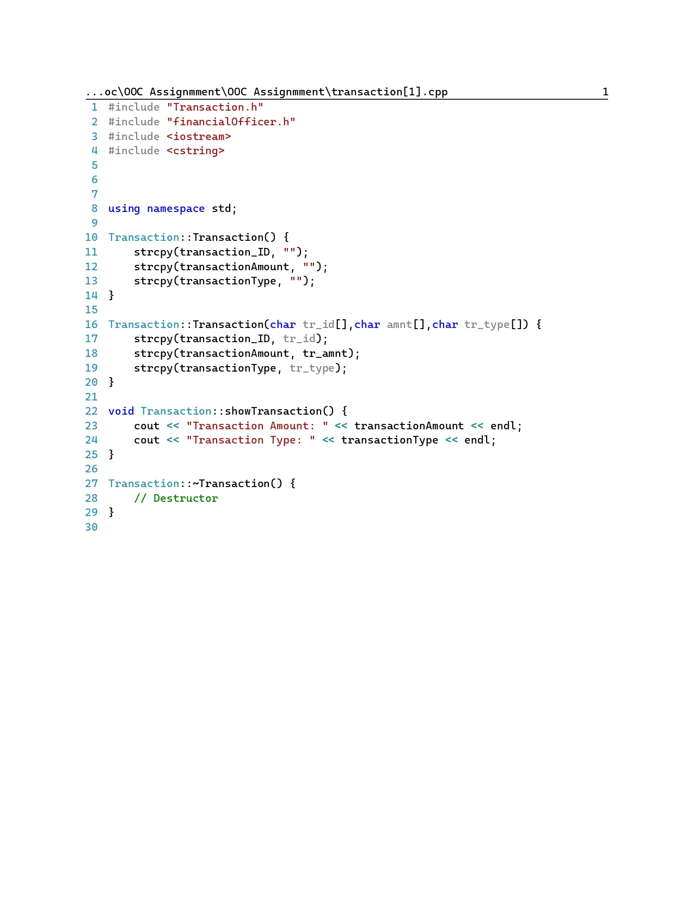**7.Transection.cpp**

# 8.Land.h and cpp file

# 

# 9.Inquiry.h

**10.Inquiry.cpp**

# 

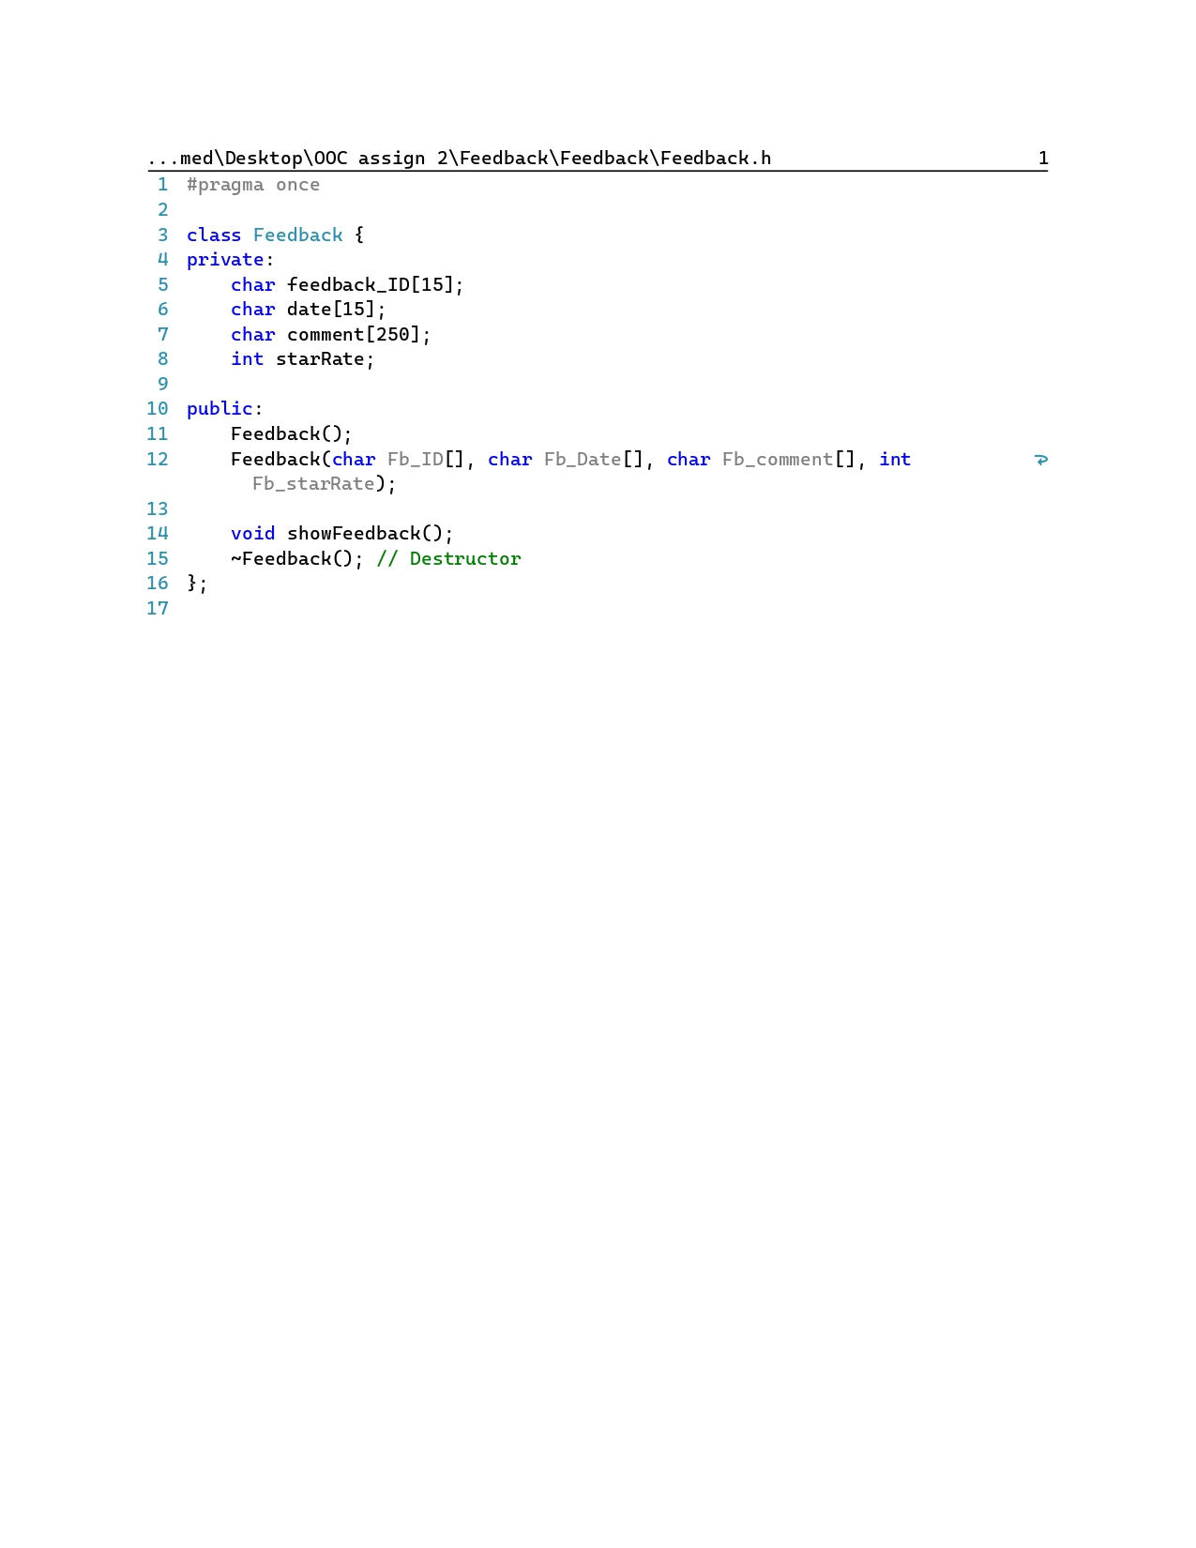**11.Feedback.h**

**12.Feedback.cpp**

# 

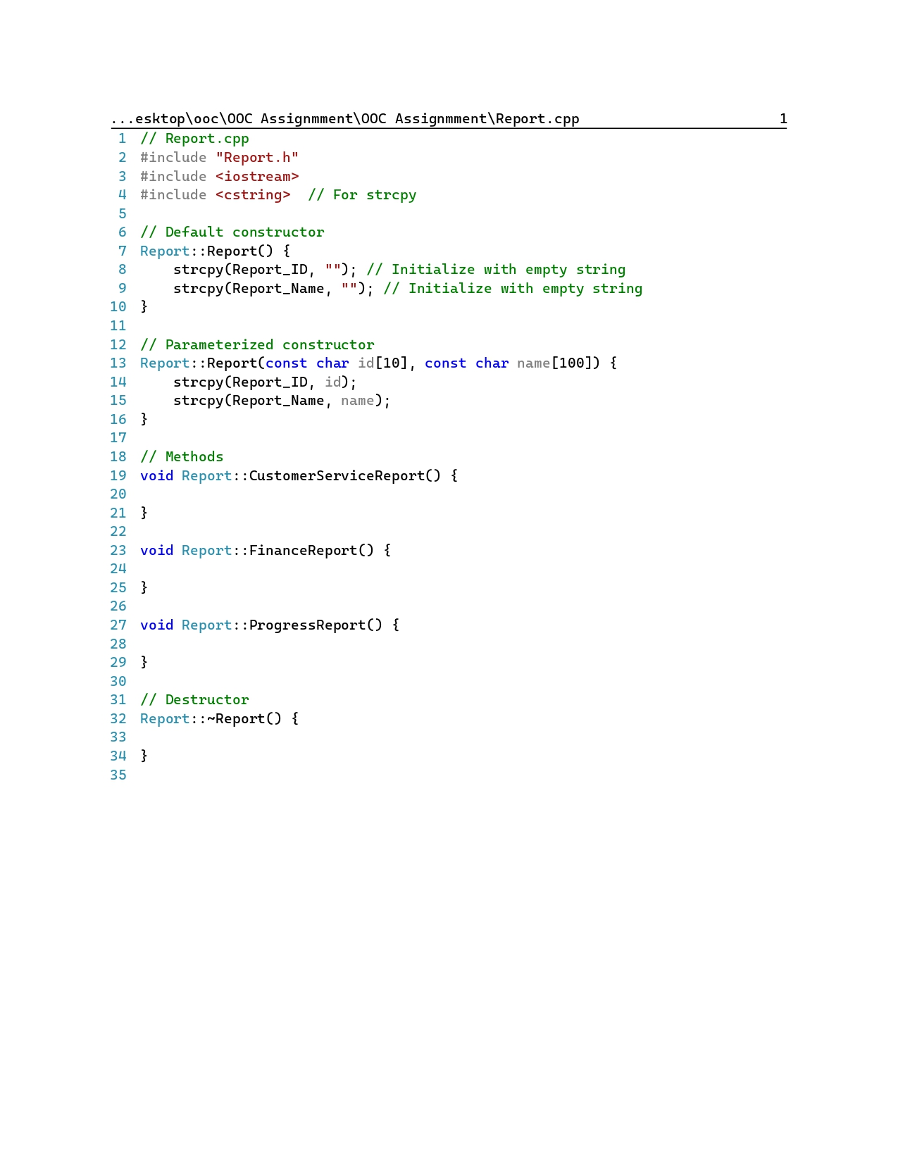**13.report.cpp**

**14.report.h**

# 

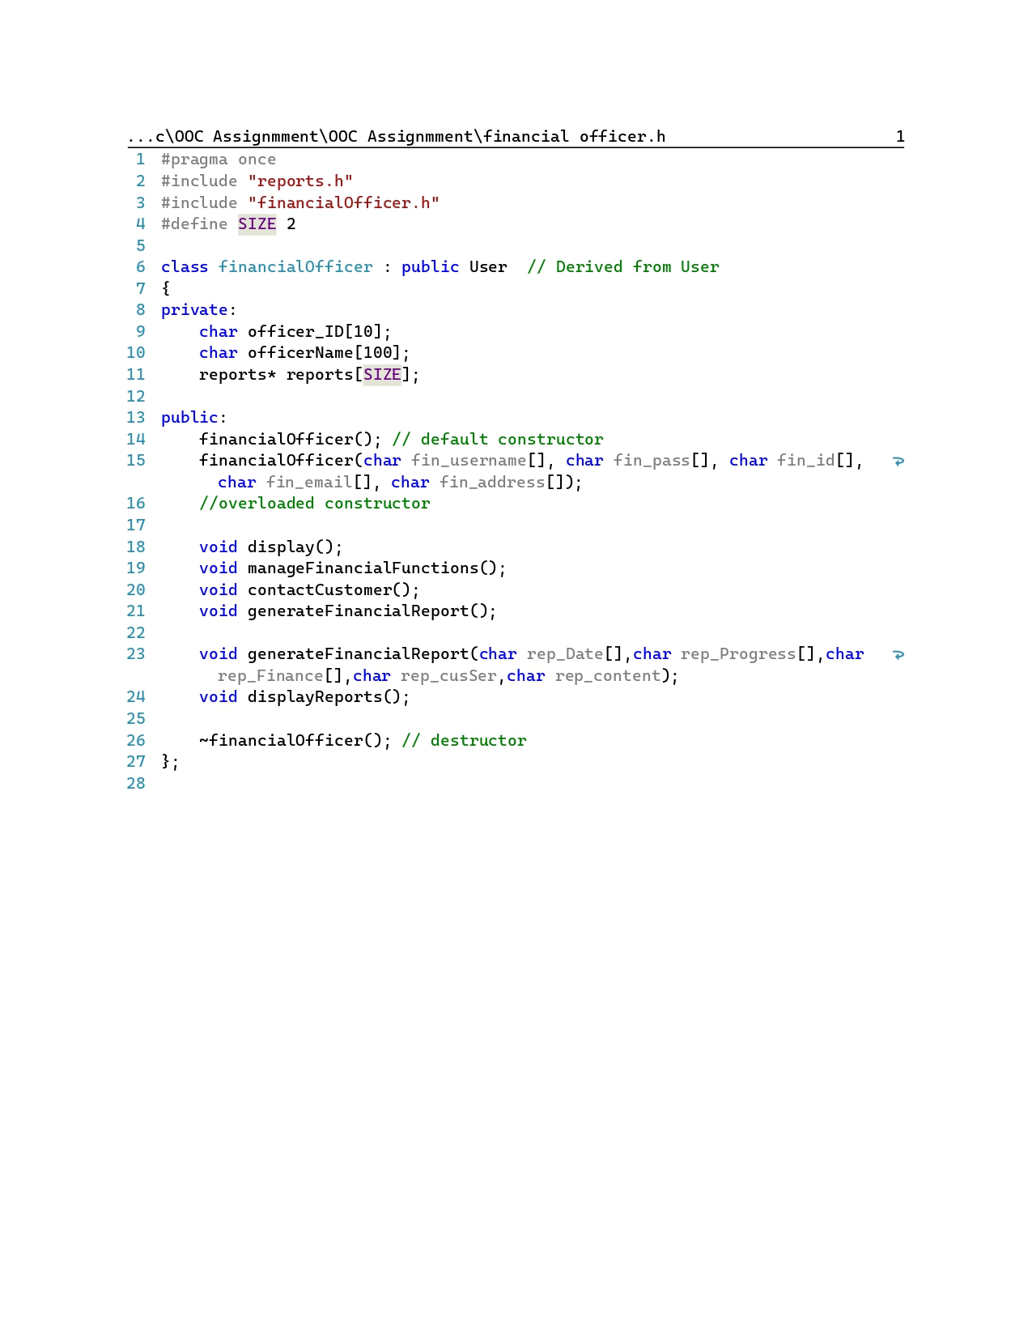**15. financial officer.h**

# 16.Financial officer.cpp

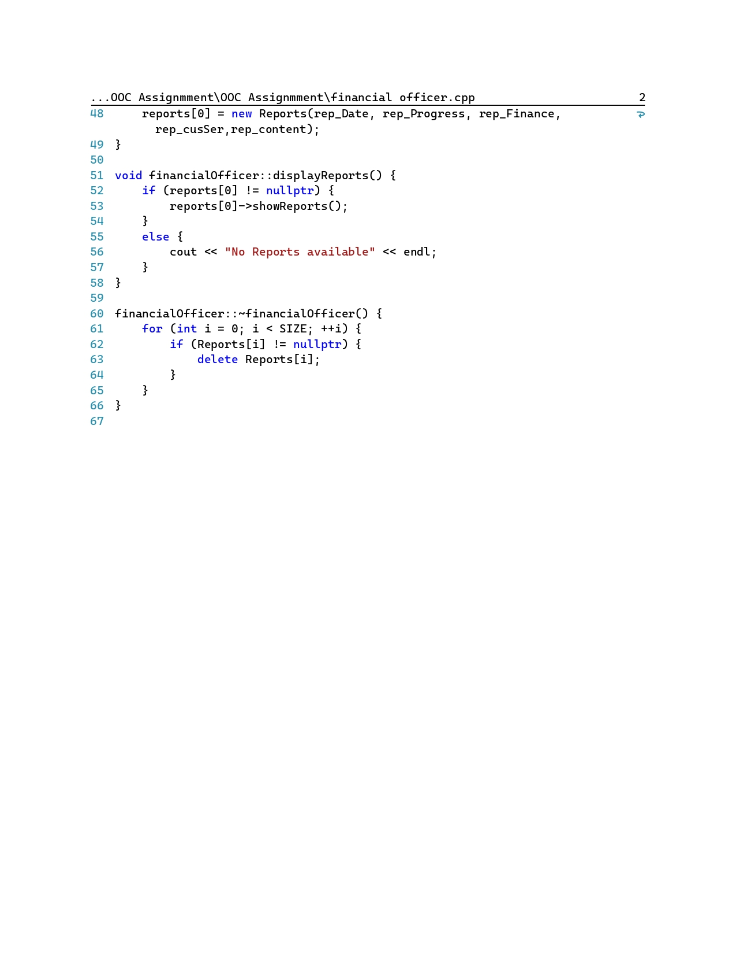

# 6.Individual Contributions

# IT23255142: HANA S.M.F

# ❖ Individual contributions

# * Created Agent and Inquiry CRC cards

# * Worked Agent and Inquiry CRC Diagram

# * Worked on creating Agent.h, Agent.cpp and Inquiry.h, Inquiry.cpp

# IT23262768: Reshma M.R.F

# ❖ Individual contributions

# * Created User and Land CRC cards

# * Worked User and Land CRC Diagram

# * Worked on creating User.h, User.cpp and Land.h, Land.cpp

# IT23151710: Aazaf Ritha J

# ❖ Individual contributions

# * Created Admin and Report CRC cards

# * Worked Admin and Report CRC Diagram

# * Worked on creating Admin.cpp , Admin.h hand Report.h, Report.cpp

# IT23187078: Aman Mohamed M. A

# ❖ Individual contributions

# * Created Registered User and Feedback CRC cards

# * Worked Registered User and Feedback CRC Diagram

# * Worked on creating RegisteredUser.h, RegisteredUser.cpp and Feedback.h, Feedback.cpp IT23238480: Ayman M R

# ❖ Individual contributions

# * Created Financial Officer and Transaction CRC cards

# * Worked Financial Officer and Transaction CRC Diagram

# * Worked on creating Financial Officer.cpp , Financial Officer.h hand Transaction.h, Transaction.cpp